./

Learning Report – Applied System Development Life Cycle and Software Testing



|  |  |  |  |  |  |
| --- | --- | --- | --- | --- | --- |
| **Ver. Rel. No.** | **Release Date** | **Prepared. By** | **Reviewed By** | **To be approved By** | **Remarks/Revision Details** |
| 1 |  | Name/PS No | Name/PS No | Module Owner Name | Comments |
| 2 | 15/02/21 | Kopparapu Jyothi Swaroopa Rani | Sourav Dey  Amiya Panda | Prithvi Sekhar  Srinivas |  |
|  |  |  |  |  |  |
|  |  |  |  |  |  |
|  |  |  |  |  |  |

**Document History**

Table of Contents

Table of Figures 3

Table of Tables 4

ACTIVITY 1: SYSTEM/ SOFTWARE DEVELOPMENT 4

**INTRODUCTION** 4

**MY PRODUCT: “Name ”** 6

**SWOT ANALYSIS** 7

**REQUIREMENTS** 7

**DESIGN** 8

HIGH LEVEL DESIGN 8

LOW LEVEL DESIGN 11

**TEST PLANS** 13

**REFERENCES** 15

ACTIVITY 2: AGILE METHODOLOGY 15

**THEME** 15

**EPIC** 15

**USER STORY** 16

**REFERENCES** 17

APPENDIX: 17

## Table of Figures

Figure 1 CLASS DIAGRAM(HIGH LEVEL) 10

Figure 2 USE CASE DIAGRAM (HIGH LEVEL) 11

Figure 3 ACTIVITY DIAGRAM (HIGH LEVEL) 12

Figure 4 USE CASE DIAGRAM (LOW LEVEL) 12

Figure 5 ACTVITY DIAGRAM (LOW LEVEL) 13

Figure 6 BLOCK DIAGRAM 13

Figure 7 COMPONENT DIAGRAM (HIGH LEVEL) 22

Figure 8 ACTIVITY DIAGRAM (high level) 23

[Figure 9 ACTIVITY DIAGRAM (LOW LEVEL) 24](https://lnttsgroup.sharepoint.com/sites/GEA/Global%20Engineering%20Academy/GEA%20Insights/Genesis/Shared%20Documents/Submission/MYSORE/2009MYSEMB/Foundation/Applied%20SDLC%20with%20Software%20Testing/99002439/FINAL.docx#_Toc52177322)

Figure 10- ACTIVITY DIAGRAM (LOW LEVEL) 24

Figure 11 TEST PLAN 25

Figure 12 GIT 27

Figure 13 GIT ISSUES 28

Figure 14 GIT COMMITS 1 28

Figure 15 GIT COMMIT 2 29

Figure 16 GIT 30

Figure 17 GIT MAKE 31

Figure 18 GIT MAKE 2 31

Figure 19 GIT BUILD 32

Figure 20 GIT CODE QUALITY 32

## Table of Tables

Table 1 AGING 6

Table 2 GRADING COST 6

Table 3 REQUIREMENTS 8

Table 4 HIGH LEVEL TEST PLAN 15

Table 5 LOW LEVEL TEST PLAN 16

Table 6 USER STORIES 17

Table 7 AGING 19

Table 8 GRADING COST 19

Table 9 REQUIREMENTS 21

Table 10 USER STORIES 27

**ACTIVITY-1**

**Introduction:**

A Smart Calculator is a user friendly and portable calculator i.e, used to perform arithmetic operations, trigonometric functions, square roots, cube roots, exponential functions, binary to decimal conversions and vice versa, history of previous functions etc.  The common components of calculator are keypad, LCD Display, Battery or solar cell.

**My Product:** Smart Calculator.

**SWOT Analysis:**

|  |
| --- |
|  |
|  | Strengths: |
|  | - Dual Power source |
|  | - Pocket Friendly |
|  | - Memory storage |
|  | - Accuracy and speed |
|  | - Attractive |
|  |  |
|  | Weakness: |
|  |  |
|  | - Less number of complex functions. |
|  | - Display digits are limited. |
|  |  |
|  | Opportunity: |
|  |  |
|  | - Can be used by a wider age group. |
|  | - As education is an important aspect in India, it will have a greater market value. |
|  |  |
|  | Threats: |
|  |  |
|  | - Competitive market. |
|  | - Application of smartphones reduces the usage of calculators. |

**Requirements:**

**High Level Requirements:**

HLR1- Arithmetic Operations

HLR2-Trignometric Functions

HLR3-Exponential Functions

HLR4-logarithmic square root and cube root

HLR5-complex functions

HLR6-History of previous expressions

HLR7-Mathprint

HLR8- square root and cube root

**Low Level Requirements:**

Trignometric Functions: Finding values for sin(), cos(), tan(), sec(), cosec(), cot() functions.

Exponential Functions: To perform logarithmic functions and cube root of a number.

|  |
| --- |
|  |

|  |
| --- |
|  |
|  |  |
|  |  |
|  |  |
|  |  |
|  |  |
|  |  |
|  |  |

**Features of Smart Calculator:**

## **1. Basic functions and exponents**

Calculate basic functions such as addition, subtraction, multiplication, and division. You should keep in mind that the subtraction sign (-) is different from a separate negative function. This can end up causing some confusion concerning negative and positive numbers when you start using your calculator at first because the signs look similar.

### Exponents, unknown numbers

Along with negation, you can also raise numbers to another power and find a square root of a number or formula.

Exponents are used in almost any math course past grade school, but only a scientific calculator can perform any algebraic function.

In addition to using your calculator to solve for a known number, you can use it for an unknown number. This is useful for algebra or any other more advanced math you may be studying.

### Order of operations

Basic calculators are great for solving simple equations with one or two variables, but scientific calculators allow you to input a problem that has an order of operations. If you enter one of these equations into a regular calculator, it won’t be able to correctly determine which numbers should be addressed first.

However, once you enter the equation into a scientific calculator, it should provide you with the correct answer. This is because parentheses are included as an option, allowing you to solve more complex problems. This tells the calculator to perform that operation first, much like if you were doing it on paper.

### Square root

It’s also possible to use a scientific calculator to find the square root of a number, and this is one of the simplest operations you can perform. Enter the number, hit the SQRT key, and your answer will appear.

### Fast or correct? Now you can do both

Often, finding the answers to equations requires just using one or two keys, which can make solving difficult problems quicker and easier.

And while most instructors now encourage calculator use in their classrooms, it’s worth asking first if this type of device is allowed. Almost anyone can benefit from using a scientific calculator.

## **2. Logarithms**

Once you have increased your knowledge and you’re learning new concepts related to calculus and trigonometry, it’s likely that you will have to learn about logarithms. These formulas help you to calculate speed, area, and much more.

In the past, these were done almost completely by hand. Now it takes only a moment to input the proper information and solve the problem using a calculator.

### Medical and engineering made easier

Logarithms are mostly used by those involved in the medical and engineering fields, but other careers may encounter them at some point. They can be tricky to solve by hand, but with the help of a scientific calculator, the process can be much easier.

Your device will probably solve for the natural logarithm of an equation in most classes. Some teachers may only explain logarithms through the use of a scientific calculator because all it requires is knowing how to enter the correct formula.

### Memory is key to solving logarithms

Another reason that you may want to consider using a scientific calculator for logarithms is that they have a built-in memory, which allows you to store certain equations.

If you are working on something that requires several sessions, you can tell your calculator to store what you have already input into the device. This makes it easy to return if you need to take a break or if you want to try another combination.

## **3. Sine, cosine, and tangent functions**

For those taking a trigonometry or calculus course, sine functions are a given. They also often pop up if your career path involves any sort of engineering or architectural field.

### Calculating the sine

A sine function is used to find the measurement of a certain angle, especially when other sides or angles are unknown. You may also encounter the inverse sine, which is often used to find the hypotenuse of a triangle.

Like logarithms, this calculation once took a while to solve as you went through one piece of paper after the next. With scientific calculators, you can get the answer almost immediately once you have properly entered the function. Look for sin, cos, and tan buttons on any calculator to make sure it includes these functions.

### Graphing the sine

Another related calculation you may have to perform is the graphing of a sine. This is a direct way to show your work and many classes now require that you know how to graph various functions.

### Cosine functions

Similarly, you can also graph and solve for cosine functions. The cosine of an angle is the measurement of the length of a triangle, and it is most often used in trigonometry courses. You’ll most likely use cosines to find the length of the hypotenuse of a triangle, and a scientific calculator also operates in the reverse with inverse cosines.

Cosines can be found for any angle, even if they are large or negative. Again, you may be required to show that you know what cosines are by using your calculator to create a graph.

### Tangents in degrees or radians

Tangents are another concept you will have to learn in a trigonometry class, and this too involves finding unknown quantities. In geometry, you’ll most likely encounter tangents when calculating perpendicular lines.

In trigonometry, you’ll use it to find the value of an opposite side of the given values. You can also choose to receive your answer in either degrees or radians depending on what your instructor requires.

Again, a scientific calculator is the only kind of calculator that can find the answer these types of equations, and it’s likely that at some point you will need them in your schooling. This can be especially true if your instructor requires that you show you know how to graph certain functions, which may be part of your final grade.

## **4. Scientific notation**

A scientific calculator isn’t just used for more complicated math problems. In fact, one of its best uses may be that it can calculate scientific notation. For numbers that can’t be written in decimal point form because they are too large, a normal calculator won’t be able to cover it.

You’ll most likely use scientific notation if you plan to work in a field related to science, engineering, and mathematics, and you will definitely need a more complex calculator to handle your homework.

If you’re wondering how to do scientific notation on a calculator, it’s not that complicated. In order to perform the operation:

* Locate the 10^x on your device
* Enter in your x value
* Press the “Enter” button in order to receive the answer

Unlike basic calculators that can only handle smaller values, a scientific calculator can handle numbers on a much vaster scale, which can be useful when it comes to collecting data or working as a physicist or chemist. It can also calculate negative scientific notation.

For those looking to enter engineering, there is a special mode that can help you calculate equations specific to your field. You’ll find it as the ENG display mode on your device, and it’s designed to help communicate numbers orally and through reading.

## **5. Binary functions**

Similar to how you would enter equations into your calculator to compute notations or logs, tangents, and sines, a scientific calculator can solve for binary functions. These equations require two inputs.

You’ll most likely encounter this in algebra or calculus when you are solving for an unknown, but you may also discuss it when learning about the Cartesian product and subsets.

This is another type of equation that is difficult to track without having a calculator that has memory, because if you can store the results the calculator gives you, you can build off the work that you have accomplished before or save your efforts for another time.

## **Cost vs Features:**

**Calculator**                **Cost                   Features**  
Basic                         170                   Addition, Subtraction, Multiplication and Division  
Scientific                     750                   log, natural log and trignometric functions  
Engineer scientific       1600                  42 built-in Physical Constants  
Financial                     3000                  The financial calculators usually have five important keys that represent the 'variables'  
Printing                       5000                  You can press TIME key to display current time and date. You can

press REPRINT key to reprint operation and calculation results.  
Graphical                     11800                 plot graphs and even solve equations  
Programmable Scientific       15000                 Programmable Scientific Calculator with 664 Functions. With Natural Textbook Display so your functions and equations look same as in your textbook. Probability, Calculus, Permutation Combination, Random Number Calculation features. Statistics (List-based Statistics, Standard deviation, Regression analysis).

**4W&1H:**

**What:** User friendly and pocket friendly Calculator.

**Who:** People of any age group can use the calculator as it is user friendly i.e, students in schools and colleges, Officer’s in industries, self- employees.

**When:** It is used for students for saving time and for Officer’s and employees for complex calculations (use Scientific calculator).

**Why:** For saving time.

**How:** By operating manually for analog calculators and using screen touch for smart calculators.

**UML Diagrams:**

**HLR Class diagram:**

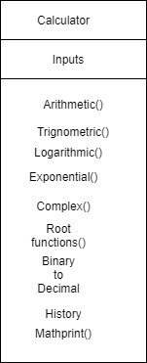

**LLR Object diagram:**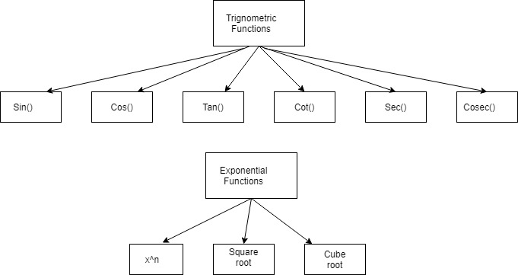

**LLR Use Case:**

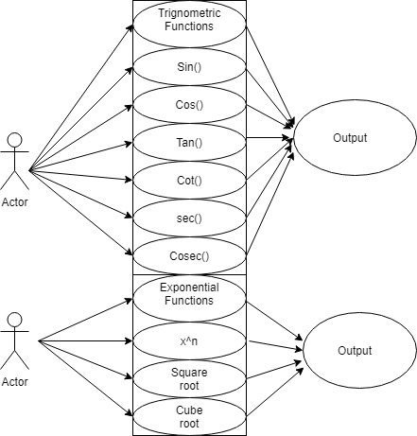

|  |  |
| --- | --- |
| **Test Cases:** |  |
| |  |  |  |  | | --- | --- | --- | --- | | **Test case ID** | **Description** | **Input** | **Expected output** | | 01 | Sine function-  positive sign of sine function results positive  negative sign of sine function results negative | Sin(30)  Sin(-30) | 0.5  -0.5 | | 02 | Cosine function-  positive sign of cos function results positive  negative sign of cos function results positive | Cos(30)  Cos(-30) | 0.8660254037844  0.8660254037844 | | 03 | Tangent function-  positive sign of cos function results positive  negative sign of cos function results negative | Tan(45)  Tan(-45) | 1  -1 | | 04 | Secant function-  positive sign of sec function results positive  negative sign of sec function results positive | Sec(30)  Sec(-30) | 6.48292123496  6.48292123496 | | 05 | coSec function-  positive sign of cosec function results positive  negative sign of cosec function results negative | coSec(30)  coSec(-30) | 2  -2 | | 06 | Cotangent function-  positive sign of cot function results positive  negative sign of cot function results negative | Cot(45)  Cot(-45) | 1  -1 | | 07 | Logarithmic Function- | Log(23) | 3.135494 | | 08 | Cube root | Cube root(27) | 3 | |  |

**Code:**

#include <stdio.h>  
#include<math.h>  
  
void Sin_fun(double Degrees_Value);  
void Cos_fun(double Degrees_Value);  
void Tan_fun(double Degrees_Value);  
void Cosec_fun(double Degrees_Value);  
void Sec_fun(double Degrees_Value);  
void Cot_fun(double Degrees_Value);  
  
int main()  
{  
    int select_option;  
    double RadianValue;  
    double Degrees_Value;  
    int ask_User;  
    do  
    {  
        printf("Enter Degrees Value\n");  
        scanf("%lf",&Degrees_Value);  
        printf("Please Choose  only one option for Trigonometry Operation\n");  
        printf(" 1. Sin\n 2. cos\n 3. Tan\n 4. Sec\n 5. Cosec \n 6. Cot\n");  
        scanf("%d",&select_option);  
        RadianValue=0.017*Degrees_Value;  
        switch(select_option)  
        {  
  
            case 1: Sin_fun(RadianValue);  
            break;  
            case 2: Cos_fun(RadianValue);  
            break;  
            case 3: Tan_fun(RadianValue);  
            break;  
            case 4: Sec_fun(RadianValue);  
            break;  
            case 5: Cosec_fun(RadianValue);  
            break;  
            case 6: Cot_fun(RadianValue);  
            break;  
            default: printf("Inavlid Input!!!! Please choose Correct option\n");  
            break;  
        }  
  
        printf("DO You want calculate again? \n1. Yes 2. No\n");  
        scanf("%d",&ask_User);  
    }  
    while(ask_User==1);  
}  
    void Sin_fun(double RadianValue ){  
        printf("\n %lf\n",sin(RadianValue));  
    }  
    void Cos_fun(double RadianValue ){  
        printf("\n %lf\n",cos(RadianValue));  
    }  
    void Tan_fun(double RadianValue ){  
        printf("\n %lf\n",tan(RadianValue));  
    }  
    void Cosec_fun(double RadianValue ){  
        printf("\n %lf\n",(1.0/sin(RadianValue)));  
    }  
    void Sec_fun(double RadianValue ){  
        printf("\n %lf\n",(1.0/cos(RadianValue)));  
    }  
    void Cot_fun(double RadianValue ){  
        printf("\n %lf\n",(1.0/tan(RadianValue)));  
    }

{  
 int ask_user;  
 int select_option;      
 float input;  
 double log_value;  
 double cuberoot_value;  
  
 printf("Please enter the value:\n");  
 scanf("%f",&input);  
 printf("Please choose only one option for special math functions:\n");  
 printf(" 1. logarithm calculation\n 2. cuberoot calculation\n");  
 scanf("%d",&select_option);  
 switch(select_option)  
 {  
    case 1 :  
    log_value = log10(input);  
    printf("logarithm of %f is %.2f\n",input,log_value);  
    break;

    case 2:  
    cuberoot_value = cbrt(input);  
    printf("cuberoot of  %f is %.2f\n",input,cuberoot_value);  
    break;  
    default:  
    printf("Invalid input!!! Please choose the correct option\n");  
    break;  
 }

**COMMITS**

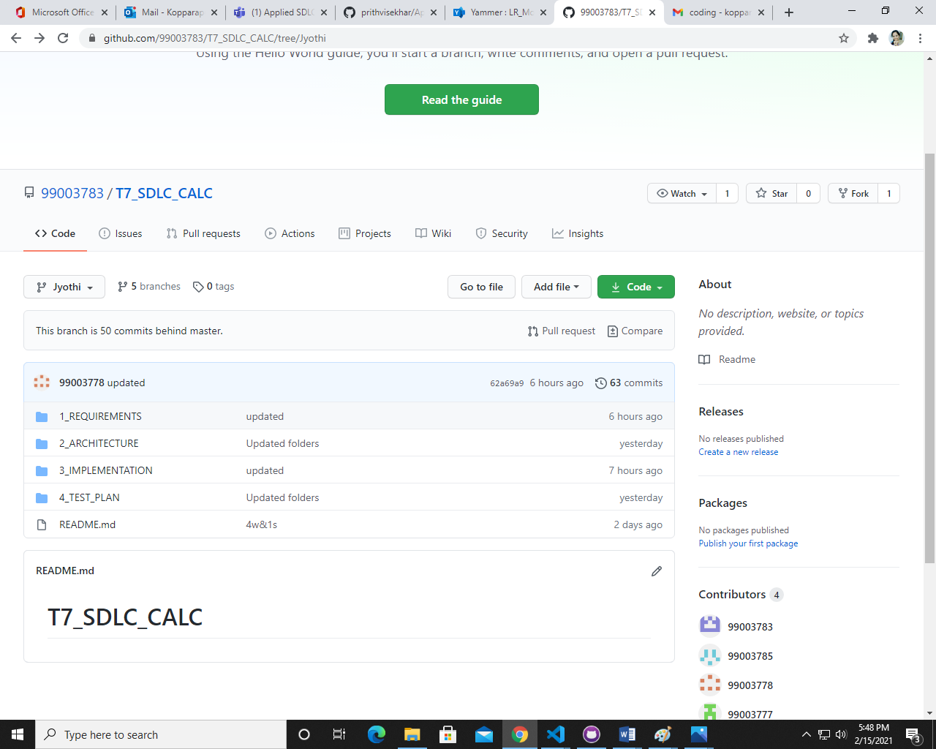

**MERGE**

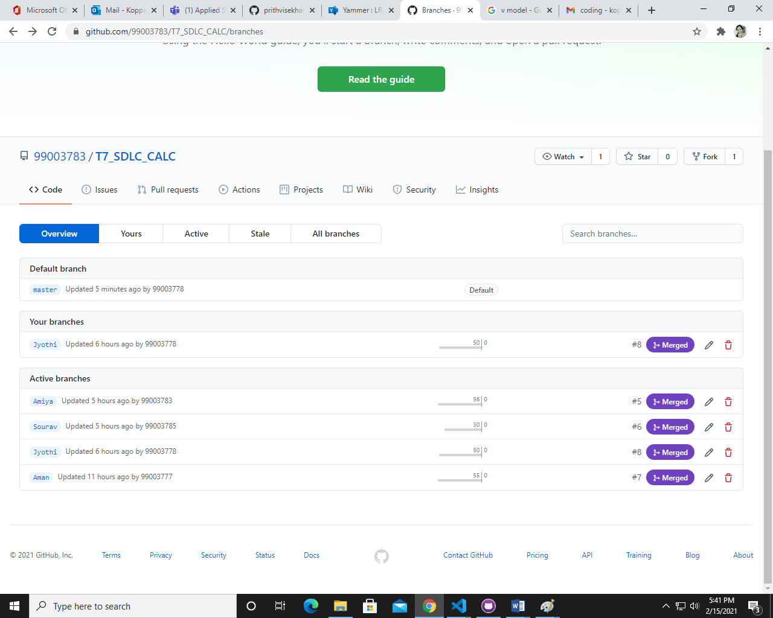

**COMMIT GRAPH**

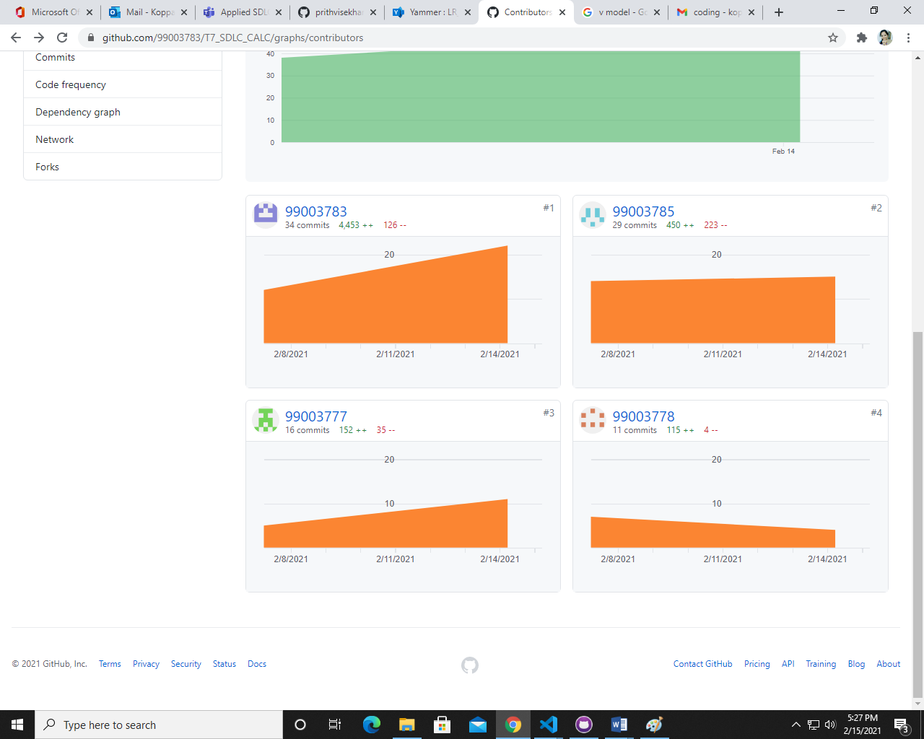

**ACTIVITY 2- AGILE METHODOLOGY (CALCULATOR)**

**THEME - Calculator :**

 Design a calculator with selected appropriate features that meets the expected requirements.

Based on the literature survey and research done, the team decided to choose educational institutions as the target customers.

**EPIC:**

**Introduction:**

The additional features in calculators enables the users in quick computation of all data type values (int, float, double) and hence results in enhanced calculation speed. Thus, there is a need for a user friendly, well featured calculators that can be affordable at

The high-level requirement features of calculator system can be divided into the following user stories:

1.     Basic arithmetic operations

2.     Trignometric Functions

3.     Logarithmic Functions

4.     Square root, cube root

5. Complex functions

6. History of previous expressions

7. MathPrint

8. Binary to decimal and vice versa

**STORIES:**

Based on the high level and low level requirements of the designed calculator, the following are the user stories from the perspective of the end user:

1.     MathPrint

2.     Basic arithmetic operations

3.     Conversions

4.     Square root, cube root

5. Complex functions

6. History of previous expressions

7. Logarithmic Functions

8. Trignometric Functions